1. מס' קבוצה: 4

2. חברי הקבוצה:

יזהר אננייב –

[Izhar_ananiev@hotmail.com](mailto:Izhar_ananiev@hotmail.com)

כפיר ביטון –

[kfirbitonn@gmail.com](mailto:kfirbitonn@gmail.com)

ליאור גל –

Liorgal28@gmail.com

איתי עלמני –

Itaialmani@gmail.com

רון בן צבי –

Benzvi.ron@gmail.com

3. תאריך הגשה : 18/11/17

# 1. Order-Requirement_Diagram

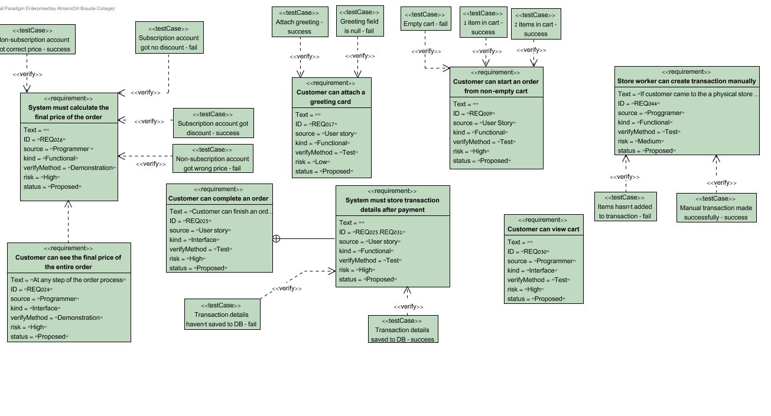

# 2. System must calculate the final price of the order

ID: REQ026

# 3. Non-subscription account got correct price - success

## 3.1. Test Plans

| Steps | Procedures | Expected Results |
| --- | --- | --- |
| 1. Add several items into cart, and manually sum their prices together | Add: -item1:5.1$ -item2:10.4$ -item3:16.7$ -item4:8.2$ | The presented final price should be 40$ |
| 2. Go the all way to the complete order window - choose the pickup option (which is free) | Enter valid data all the way |  |
| 3. Compare presented final price to expected final price |  | The final price is 40$ |

## 3.2. Relationships

| Relationship | From | To |
| --- | --- | --- |
| unnamed | Non-subscription account got correct price - success | System must calculate the final price of the order |

# 4. Non-subscription account got wrong price - fail

## 4.1. Test Plans

| Steps | Procedures | Expected Results |
| --- | --- | --- |
| 1. Add several items into cart, and manually sum their prices together | Add: -item1:5.1$ -item2:10.4$ -item3:16.7$ -item4:8.2$ | The presented final price should be 40$ |
| 2. Go the all way to the complete order window - choose the pickup option (which is free) | Enter valid data all the way |  |
| 3. Compare presented final price to expected final price |  | The final price is 38$ |

## 4.2. Relationships

| Relationship | From | To |
| --- | --- | --- |
| unnamed | Non-subscription account got wrong price - fail | System must calculate the final price of the order |

# 5. Subscription account got discount - success

## 5.1. Test Plans

| Steps | Procedures | Expected Results |
| --- | --- | --- |
| 1. Add several items into cart, and manually sum their prices together. The presented final price should be 20$ after 50% off | Add: -item1:5.1$ -item2:10.4$ -item3:16.7$ -item4:8.2$ |  |
| 2. Go the all way to the complete order window - choose the pickup option (which is free) | Enter valid data all the way |  |
| 3. |  | The price is 20$ |

## 5.2. Relationships

| Relationship | From | To |
| --- | --- | --- |
| unnamed | Subscription account got discount - success | System must calculate the final price of the order |

# 6. Subscription account got no discount - fail

The discount for example is 50% off

## 6.1. Test Plans

| Steps | Procedures | Expected Results |
| --- | --- | --- |
| 1. Add several items into cart, and manually sum their prices together. The presented final price should be 20$ after 50% off | Add: -item1:5.1$ -item2:10.4$ -item3:16.7$ -item4:8.2$ |  |
| 2. Go the all way to the complete order window - choose the pickup option (which is free) | Enter valid data all the way |  |
| 3. |  | The price is 40$ |

## 6.2. Relationships

| Relationship | From | To |
| --- | --- | --- |
| unnamed | Subscription account got no discount - fail | System must calculate the final price of the order |

# 7. Customer can see the final price of the entire order

ID: REQ024

At any step of the order process

# 8. System must store transaction details after payment

ID: REQ025.REQ031

# 9. Transaction details saved to DB - success

## 9.1. Test Plans

| Steps | Procedures | Expected Results |
| --- | --- | --- |
| 1. System get transaction details |  |  |
| 2. System trying to save transaction details to DB |  |  |
| 3. Save succeeded |  |  |

## 9.2. Relationships

| Relationship | From | To |
| --- | --- | --- |
| unnamed | Transaction details saved to DB - success | System must store transaction details after payment |

# 10. Transaction details haven't saved to DB - fail

## 10.1. Test Plans

| Steps | Procedures | Expected Results |
| --- | --- | --- |
| 1. System get transaction details |  |  |
| 2. System trying to save transaction details to DB |  |  |
| 3. Save to DB failed |  |  |

## 10.2. Relationships

| Relationship | From | To |
| --- | --- | --- |
| unnamed | Transaction details haven't saved to DB - fail | System must store transaction details after payment |

# 11. Customer can attach a greeting card

ID: REQ017

# 12. Attach greeting - success

## 12.1. Test Plans

| Steps | Procedures | Expected Results |
| --- | --- | --- |
| 1. Enter greeting information | Enter: -Greeting Content: Happy birthday Kfir :-) | Enter data appear in form |
| 2. Submit the form | Click the 'Attach' button | Prompt: Greeting attached successfully |

## 12.2. Relationships

| Relationship | From | To |
| --- | --- | --- |
| unnamed | Attach greeting - success | Customer can attach a greeting card |

# 13. Greeting field is null - fail

## 13.1. Test Plans

| Steps | Procedures | Expected Results |
| --- | --- | --- |
| 1. Enter greeting information | Enter: -Greeting Content: null | Enter data appear in form |
| 2. Submit the form | Click the 'Attach' button | Prompt: Greeting content must be filled! |

## 13.2. Relationships

| Relationship | From | To |
| --- | --- | --- |
| unnamed | Greeting field is null - fail | Customer can attach a greeting card |

# 14. Customer can start an order from non-empty cart

ID: REQ009

# 15. Empty cart - fail

## 15.1. Test Plans

| Steps | Procedures | Expected Results |
| --- | --- | --- |
| 1. Cart contains 0 items |  | Cart containment is being shown |
| 2. Start an order | Click 'Continue' button | Prompt: order must contain at least 1 item |

## 15.2. Relationships

| Relationship | From | To |
| --- | --- | --- |
| unnamed | Empty cart - fail | Customer can start an order from non-empty cart |

# 16. 1 item in cart - success

## 16.1. Test Plans

| Steps | Procedures | Expected Results |
| --- | --- | --- |
| 1. Cart contains 1 items | Add 1 items to cart | Cart containment is being shown |
| 2. Start an order | Click 'Continue' button | System forwarded to first stage of order |

## 16.2. Relationships

| Relationship | From | To |
| --- | --- | --- |
| unnamed | 1 item in cart - success | Customer can start an order from non-empty cart |

# 17. 2 items in cart - success

## 17.1. Test Plans

| Steps | Procedures | Expected Results |
| --- | --- | --- |
| 1. Cart contains 2 items | Add 2 items to cart | Cart containment is being shown |
| 2. Start an order | Click 'Continue' button | System forwarded to first stage of order |

## 17.2. Relationships

| Relationship | From | To |
| --- | --- | --- |
| unnamed | 2 items in cart - success | Customer can start an order from non-empty cart |

# 18. Store worker can create transaction manually

ID: REQ044

If customer came to the a physical store and chose to buy item(s) from the shelf for example

# 19. Manual transaction made successfully - success

## 19.1. Test Plans

| Steps | Procedures | Expected Results |
| --- | --- | --- |
| 1. Enter items IDs | Enter: -IDs: 1,2,3 | Entered data appear in form |
| 2. Submit form | Click 'Send' button | Prompt: Transaction made successfully |

## 19.2. Relationships

| Relationship | From | To |
| --- | --- | --- |
| unnamed | Manual transaction made successfully - success | Store worker can create transaction manually |

# 20. Items hasn't added to transaction - fail

The store worker has to add manually the items's IDs to the transaction

## 20.1. Test Plans

| Steps | Procedures | Expected Results |
| --- | --- | --- |
| 1. Enter items IDs | Enter: -IDs: null | Entered data appear in form |
| 2. Sumbit form | Click 'Send' button | Prompt: transaction must contain at least one item |

## 20.2. Relationships

| Relationship | From | To |
| --- | --- | --- |
| unnamed | Items hasn't added to transaction - fail | Store worker can create transaction manually |

# 21. Delivery-ReuqirementDiagram

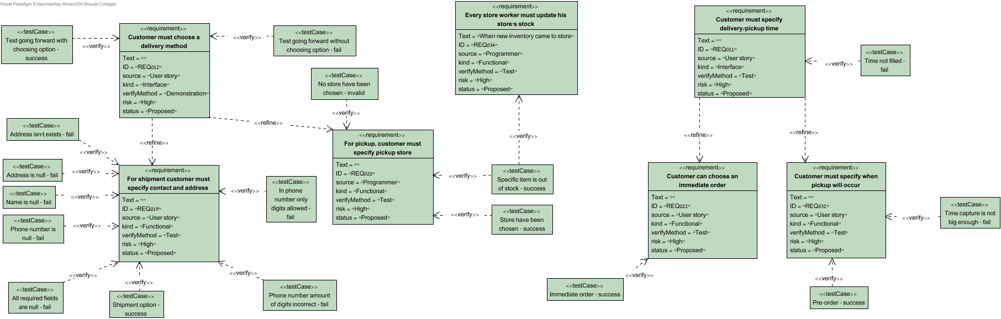

# 22. For pickup, customer must specify pickup store

ID: REQ020

# 23. No store have been chosen - invalid

## 23.1. Test Plans

| Steps | Procedures | Expected Results |
| --- | --- | --- |
| 1. Enter user information | Choose: Store: null | Enter data appear in form |
| 2. Submit the form | Click the send button | Prompt: You have to choose a store for pickup |

## 23.2. Relationships

| Relationship | From | To |
| --- | --- | --- |
| unnamed | No store have been chosen - invalid | For pickup, customer must specify pickup store |

# 24. Specific item is out of stock - success

## 24.1. Test Plans

| Steps | Procedures | Expected Results |
| --- | --- | --- |
| 1. Enter user information | Enter: -Store: Karmiel | Enter data appear in form |
| 2. Submit the form | Click the send button | Prompt: Item is out of stock at 'Karmiel' |

## 24.2. Relationships

| Relationship | From | To |
| --- | --- | --- |
| unnamed | Specific item is out of stock - success | For pickup, customer must specify pickup store |
| unnamed | Specific item is out of stock - success | Every store worker must update his store's stock |

# 25. Store have been chosen - success

## 25.1. Test Plans

| Steps | Procedures | Expected Results |
| --- | --- | --- |
| 1. Enter user information | Choose: -Store: Karmiel | Enter data appear in form |
| 2. Submit the form | Click the send button | Prompt: Application is submitted |

## 25.2. Relationships

| Relationship | From | To |
| --- | --- | --- |
| unnamed | Store have been chosen - success | For pickup, customer must specify pickup store |

# 26. For shipment customer must specify contact and address

ID: REQ019

# 27. Address isn't exists - fail

## 27.1. Test Plans

| Steps | Procedures | Expected Results |
| --- | --- | --- |
| 1. Enter user information | Enter: -Name: null -Address: 51st Izhar st., Karmiel -Phone number: 0541234567 | Enter data appear in form |
| 2. Submit the form | Click the send button | Prompt: Such address isn't exists |

## 27.2. Relationships

| Relationship | From | To |
| --- | --- | --- |
| unnamed | Address isn't exists - fail | For shipment customer must specify contact and address |

# 28. Address is null - fail

## 28.1. Test Plans

| Steps | Procedures | Expected Results |
| --- | --- | --- |
| 1. Enter user information | Enter: -Name: Jacob -Address: null -Phone number: 0541234567 | Enter data appear in form |
| 2. Submit the form | Click the send button | Prompt: All fields must be filled |

## 28.2. Relationships

| Relationship | From | To |
| --- | --- | --- |
| unnamed | Address is null - fail | For shipment customer must specify contact and address |

# 29. Name is null - fail

## 29.1. Test Plans

| Steps | Procedures | Expected Results |
| --- | --- | --- |
| 1. Enter user information | Enter: -Name: null -Address: 51st Snonit st., Karmiel -Phone number: 0541234567 | Enter data appear in form |
| 2. Submit the form | Click the send button | Prompt: All fields must be filled |

## 29.2. Relationships

| Relationship | From | To |
| --- | --- | --- |
| unnamed | Name is null - fail | For shipment customer must specify contact and address |

# 30. Phone number is null - fail

## 30.1. Test Plans

| Steps | Procedures | Expected Results |
| --- | --- | --- |
| 1. Enter user information | Enter: -Name: Jacob -Address: 51st Snonit st., Karmiel -Phone number: null | Enter data appear in form |
| 2. Submit the form | Click the send button | Prompt: All fields must be filled |

## 30.2. Relationships

| Relationship | From | To |
| --- | --- | --- |
| unnamed | Phone number is null - fail | For shipment customer must specify contact and address |

# 31. All required fields are null - fail

## 31.1. Test Plans

| Steps | Procedures | Expected Results |
| --- | --- | --- |
| 1. Enter user information | Enter: -Name: null -Address: null -Phone number: null | Enter data appear in form |
| 2. Submit the form | Click the send button | Prompt: All fields must be filled |

## 31.2. Relationships

| Relationship | From | To |
| --- | --- | --- |
| unnamed | All required fields are null - fail | For shipment customer must specify contact and address |

# 32. Shipment option - success

## 32.1. Test Plans

| Steps | Procedures | Expected Results |
| --- | --- | --- |
| 1. Enter user information | Enter: -Name: Jacob -Address: 51st Snonit st., Karmiel -Phone number: 0541234567 | Enter data appear in form |
| 2. Submit the form | Click the send button | Prompt: Application is submitted |

## 32.2. Relationships

| Relationship | From | To |
| --- | --- | --- |
| unnamed | Shipment option - success | For shipment customer must specify contact and address |

# 33. Phone number amount of digits incorrect - fail

## 33.1. Test Plans

| Steps | Procedures | Expected Results |
| --- | --- | --- |
| 1. Enter user information | Enter: -Name: null -Address: 51st Snonit st., Karmiel -Phone number: 41234567 | Enter data appear in form |
| 2. Submit the form | Click the send button | Prompt: Phone number must contain 10 digits |

## 33.2. Relationships

| Relationship | From | To |
| --- | --- | --- |
| unnamed | Phone number amount of digits incorrect - fail | For shipment customer must specify contact and address |

# 34. In phone number only digits allowed - fail

## 34.1. Test Plans

| Steps | Procedures | Expected Results |
| --- | --- | --- |
| 1. Enter user information | Enter: -Name: null -Address: 51st Snonit st., Karmiel -Phone number: AB41234567 | Enter data appear in form |
| 2. Submit the form | Click the send button | Prompt: Phone number must contain only 10 digits |

## 34.2. Relationships

| Relationship | From | To |
| --- | --- | --- |
| unnamed | In phone number only digits allowed - fail | For shipment customer must specify contact and address |

# 35. Every store worker must update his store's stock

ID: REQ034

When new inventory came to store

# 36. Specific item is out of stock - success

## 36.1. Test Plans

| Steps | Procedures | Expected Results |
| --- | --- | --- |
| 1. Enter user information | Enter: -Store: Karmiel | Enter data appear in form |
| 2. Submit the form | Click the send button | Prompt: Item is out of stock at 'Karmiel' |

## 36.2. Relationships

| Relationship | From | To |
| --- | --- | --- |
| unnamed | Specific item is out of stock - success | For pickup, customer must specify pickup store |
| unnamed | Specific item is out of stock - success | Every store worker must update his store's stock |

# 37. Customer can choose an immediate order

ID: REQ022

# 38. Immediate order - success

## 38.1. Test Plans

| Steps | Procedures | Expected Results |
| --- | --- | --- |
| 1. Enter user information | Enter: -Date: 01/01/17 -Time: immediate | Enter data appear in form |
| 2. Submit the form | Click the send button | Prompt: Application been submitted |

## 38.2. Relationships

| Relationship | From | To |
| --- | --- | --- |
| unnamed | Immediate order - success | Customer can choose an immediate order |

# 39. Customer must specify when pickup will occur

ID: REQ032

# 40. Pre-order - success

Assuming right now the date is 01/01/17 and the time is 10:00.

## 40.1. Test Plans

| Steps | Procedures | Expected Results |
| --- | --- | --- |
| 1. Enter user information | Enter: -Date: 02/01/17 -Time: 10:00 | Enter data appear in form |
| 2. Submit the form | Click the send button | Prompt: Application been submitted |

## 40.2. Relationships

| Relationship | From | To |
| --- | --- | --- |
| unnamed | Pre-order - success | Customer must specify when pickup will occur |

# 41. Time capture is not big enough - fail

Assuming right now the date is 01/01/17 and the time is 10:00

## 41.1. Test Plans

| Steps | Procedures | Expected Results |
| --- | --- | --- |
| 1. Enter user information | Enter: -Date: 01/01/17 -Time: 12:00 | Enter data appear in form |
| 2. Submit the form | Click the send button | Prompt: You can't pick time that is less than 3 hours from current time! |

## 41.2. Relationships

| Relationship | From | To |
| --- | --- | --- |
| unnamed | Time capture is not big enough - fail | Customer must specify when pickup will occur |

# 42. Items-RequirementDiagram

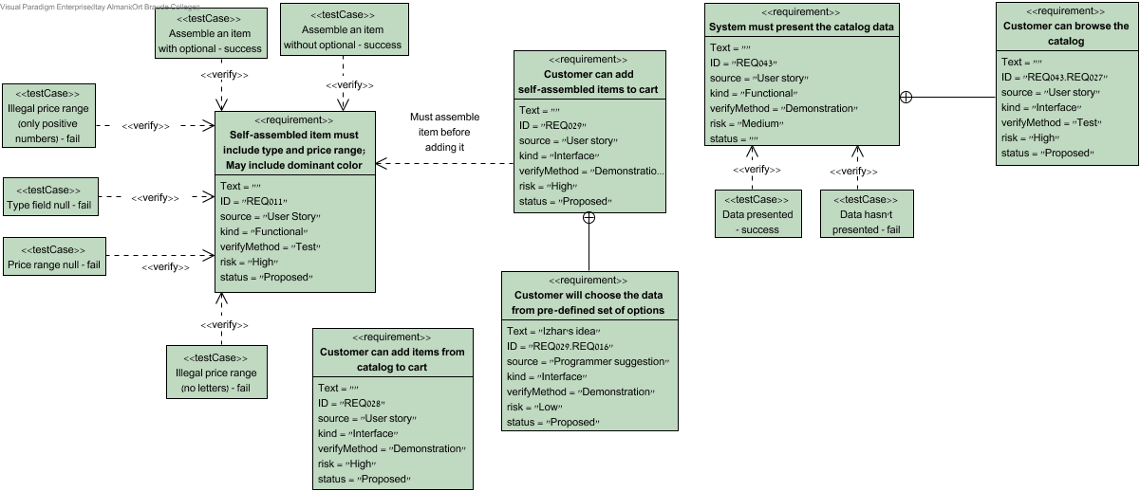

# 43. Self-assembled item must include type and price range; May include dominant color

ID: REQ011

# 44. Assemble an item without optional - success

All required fields are filled and all the data is valid an correct.

Optional fields haven't been filled.

## 44.1. Test Plans

| Steps | Procedures | Expected Results |
| --- | --- | --- |
| 1. Enter user information | Enter: -Type: flower arrangement -Desirable Price Range: 20-30$ -Dominant Color: null | Enter data appear in form |
| 2. Submit the form | Click the send button | Prompt: Application is submitted |

## 44.2. Relationships

| Relationship | From | To |
| --- | --- | --- |
| unnamed | Assemble an item without optional - success | Self-assembled item must include type and price range; May include dominant color |

# 45. Assemble an item with optional - success

## 45.1. Test Plans

| Steps | Procedures | Expected Results |
| --- | --- | --- |
| 1. Enter user information | Enter: -Type: flower arrangement -Desirable Price Range: 20-30$ -Dominant Color: Green | Enter data appear in form |
| 2. Submit the form | Click the send button | Prompt: Application is submitted |

## 45.2. Relationships

| Relationship | From | To |
| --- | --- | --- |
| unnamed | Assemble an item with optional - success | Self-assembled item must include type and price range; May include dominant color |

# 46. Illegal price range (only positive numbers) - fail

## 46.1. Test Plans

| Steps | Procedures | Expected Results |
| --- | --- | --- |
| 1. Enter user information | Enter: *Type: flower arrangement *Desirable Price Range: -10:20$ *Dominant Color: null | Enter data appear in form |
| 2. Submit the form | Click the send button | Prompt: Price can't be negative |

## 46.2. Relationships

| Relationship | From | To |
| --- | --- | --- |
| unnamed | Illegal price range (only positive numbers) - fail | Self-assembled item must include type and price range; May include dominant color |

# 47. Illegal price range (no letters) - fail

## 47.1. Test Plans

| Steps | Procedures | Expected Results |
| --- | --- | --- |
| 1. Enter user information | Enter: *Type: flower arrangement *Desirable Price Range: AA:BB$ *Dominant Color: null | Enter data appear in form |
| 2. Sumbit the form | Click the send button | Prompt: Price can include only digits |

## 47.2. Relationships

| Relationship | From | To |
| --- | --- | --- |
| unnamed | Illegal price range (no letters) - fail | Self-assembled item must include type and price range; May include dominant color |

# 48. Type field null - fail

## 48.1. Test Plans

| Steps | Procedures | Expected Results |
| --- | --- | --- |
| 1. Enter user information | Enter: -Type: null -Desirable Price Range: 20-30$ -Dominant Color: null | Enter data appear in form |
| 2. Submit the form | Click the send button | Prompt: Type is null |

## 48.2. Relationships

| Relationship | From | To |
| --- | --- | --- |
| unnamed | Type field null - fail | Self-assembled item must include type and price range; May include dominant color |

# 49. Price range null - fail

## 49.1. Test Plans

| Steps | Procedures | Expected Results |
| --- | --- | --- |
| 1. Enter user information | Enter: -Type: flower arrangement -Desirable Price Range: null -Dominant Color: null | Enter data appear in form |
| 2. Sumbit the form | Click the send button | Prompt: Desirable Price Range is null |

## 49.2. Relationships

| Relationship | From | To |
| --- | --- | --- |
| unnamed | Price range null - fail | Self-assembled item must include type and price range; May include dominant color |

# 50. System must present the catalog data

ID: REQ043

# 51. Data presented - success

## 51.1. Test Plans

| Steps | Procedures | Expected Results |
| --- | --- | --- |
| 1. System loading all items from catalog |  |  |
| 2. All items loaded successfully into the page |  | Items loaded successfully |

## 51.2. Relationships

| Relationship | From | To |
| --- | --- | --- |
| unnamed | Data presented - success | System must present the catalog data |

# 52. Data hasn't presented - fail

## 52.1. Test Plans

| Steps | Procedures | Expected Results |
| --- | --- | --- |
| 1. System loading all items from catalog |  |  |
| 2. All items loaded not successfully into the page |  | Items loaded not successfully |

## 52.2. Relationships

| Relationship | From | To |
| --- | --- | --- |
| unnamed | Data hasn't presented - fail | System must present the catalog data |

# 53. RD - Management 1st

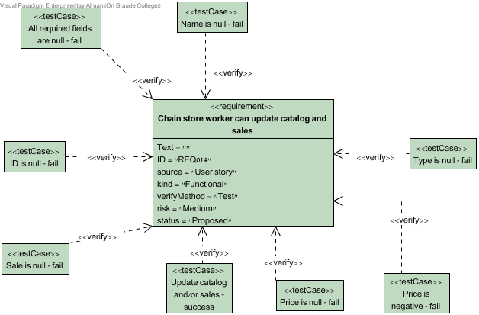

# 54. Chain store worker can update catalog and sales

ID: REQ014

# 55. All required fields are null - fail

## 55.1. Test Plans

| Steps | Procedures | Expected Results |
| --- | --- | --- |
| 1. Open catalog | Enter: -ID:null -Name:null -Type:null -Price: null -On sale: null | Data appeared in form |
| 2. Submit the form | click send | Prompt: please fill the form again! |

## 55.2. Relationships

| Relationship | From | To |
| --- | --- | --- |
| unnamed | All required fields are null - fail | Chain store worker can update catalog and sales |

# 56. ID is null - fail

## 56.1. Test Plans

| Steps | Procedures | Expected Results |
| --- | --- | --- |
| 1. Open catalog | Enter: -ID:null -Name:Rose -Type: Rosaceae -Price: 15 -On sale: no | Data appeared in form |
| 2. Submit the form | click send | Prompt: ID is missing! |

## 56.2. Relationships

| Relationship | From | To |
| --- | --- | --- |
| unnamed | ID is null - fail | Chain store worker can update catalog and sales |

# 57. Name is null - fail

## 57.1. Test Plans

| Steps | Procedures | Expected Results |
| --- | --- | --- |
| 1. Open catalog | Enter: -ID:111 -Name:null -Type: Rosaceae -Price: 15 -On sale: no | Data appeared in form |
| 2. Submit the form | click send | prompt: Name is missing! |

## 57.2. Relationships

| Relationship | From | To |
| --- | --- | --- |
| unnamed | Name is null - fail | Chain store worker can update catalog and sales |

# 58. Price is negative - fail

## 58.1. Test Plans

| Steps | Procedures | Expected Results |
| --- | --- | --- |
| 1. Open catalog | Enter: -ID:111 -Name:Rose -Type: Rosaceae -Price: -15555 -On sale: no | Data appeared in form |
| 2. Submit the form | click send | prompt: price have negative value! |

## 58.2. Relationships

| Relationship | From | To |
| --- | --- | --- |
| unnamed | Price is negative - fail | Chain store worker can update catalog and sales |

# 59. Price is null - fail

## 59.1. Test Plans

| Steps | Procedures | Expected Results |
| --- | --- | --- |
| 1. Open catalog | Enter: -ID:111 -Name:Rose -Type: Rosaceae -Price: null -On sale: no | Data appeared in form |
| 2. Submit the form | click send | Prompt: Price is missing! |

## 59.2. Relationships

| Relationship | From | To |
| --- | --- | --- |
| unnamed | Price is null - fail | Chain store worker can update catalog and sales |

# 60. Sale is null - fail

## 60.1. Test Plans

| Steps | Procedures | Expected Results |
| --- | --- | --- |
| 1. Open catalog | Enter: -ID:111 -Name:Rose -Type: Rosaceae -Price: 15 -On sale: null | Data appeared in form |
| 2. Submit the form | Click send | Prompt: On sale is missing! |

## 60.2. Relationships

| Relationship | From | To |
| --- | --- | --- |
| unnamed | Sale is null - fail | Chain store worker can update catalog and sales |

# 61. Type is null - fail

## 61.1. Test Plans

| Steps | Procedures | Expected Results |
| --- | --- | --- |
| 1. Open catalog | Enter: -ID:111 -Name:Rose -Type:null -Price: 15 -On sale: no | Data appeared in form |
| 2. Submit the form | click send | prompt: Type is missing! |

## 61.2. Relationships

| Relationship | From | To |
| --- | --- | --- |
| unnamed | Type is null - fail | Chain store worker can update catalog and sales |

# 62. Update catalog and/or sales - success

## 62.1. Test Plans

| Steps | Procedures | Expected Results |
| --- | --- | --- |
| 1. Open catalog | Enter: -ID:111 -Name:Rose -Type: Rosaceae -Price: 15 -On sale: no | Data appeared in form |
| 2. Submit the form | click send | prompt: catalog updated successfully! |

## 62.2. Relationships

| Relationship | From | To |
| --- | --- | --- |
| unnamed | Update catalog and/or sales - success | Chain store worker can update catalog and sales |

# 63. RD - Management 2nd

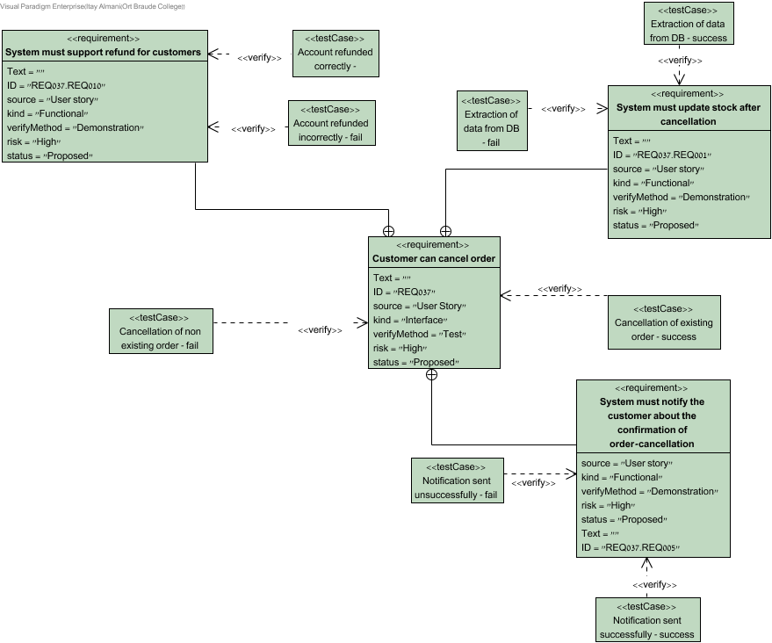

# 64. System must support refund for customers

ID: REQ037.REQ010

# 65. Account refunded correctly - success

There are 3 options: No refund, Partial refund, Full partial

## 65.1. Test Plans

| Steps | Procedures | Expected Results |
| --- | --- | --- |
| 1. System extracts the data from DB |  |  |
| 2. Check if customer deserves refund | System calculate difference between cancellation time to delivery time | The customer refunded correctly |

## 65.2. Relationships

| Relationship | From | To |
| --- | --- | --- |
| unnamed | Account refunded correctly - success | System must support refund for customers |

# 66. Account refunded incorrectly - fail

## 66.1. Test Plans

| Steps | Procedures | Expected Results |
| --- | --- | --- |
| 1. System extracts the data from DB |  |  |
| 2. Check if customer deserves refund | System calculate difference between cancellation time to delivery time | The customer refunded incorrectly |

## 66.2. Relationships

| Relationship | From | To |
| --- | --- | --- |
| unnamed | Account refunded incorrectly - fail | System must support refund for customers |

# 67. System must update stock after cancellation

ID: REQ037.REQ001

# 68. Extraction of data from DB - success

## 68.1. Test Plans

| Steps | Procedures | Expected Results |
| --- | --- | --- |
| 1. System extracts the data from DB |  |  |
| 2. Check if stock updated correctly | The system check the stock after cancellation of order | Stock is up to date |

## 68.2. Relationships

| Relationship | From | To |
| --- | --- | --- |
| unnamed | Extraction of data from DB - success | System must update stock after cancellation |

# 69. Extraction of data from DB - fail

## 69.1. Test Plans

| Steps | Procedures | Expected Results |
| --- | --- | --- |
| 1. System extracts the data from DB |  |  |
| 2. Check if stock updated correctly | The system check the stock after cancellation of order | Stock isn't up to date |

## 69.2. Relationships

| Relationship | From | To |
| --- | --- | --- |
| unnamed | Extraction of data from DB - fail | System must update stock after cancellation |

# 70. System must notify the customer about the confirmation of order-cancellation

ID: REQ037.REQ005

# 71. Notification sent unsuccessfully - fail

## 71.1. Test Plans

| Steps | Procedures | Expected Results |
| --- | --- | --- |
| 1. System receives order cancellation request | System process cancel request | Notification isn't sent successfully |

## 71.2. Relationships

| Relationship | From | To |
| --- | --- | --- |
| unnamed | Notification sent unsuccessfully - fail | System must notify the customer about the confirmation of order-cancellation |

# 72. Notification sent successfully - success

## 72.1. Test Plans

| Steps | Procedures | Expected Results |
| --- | --- | --- |
| 1. System receives order cancellation request | System process cancel request | Notification sent successfully |

## 72.2. Relationships

| Relationship | From | To |
| --- | --- | --- |
| unnamed | Notification sent successfully - success | System must notify the customer about the confirmation of order-cancellation |

# 73. RD - Management 3rd

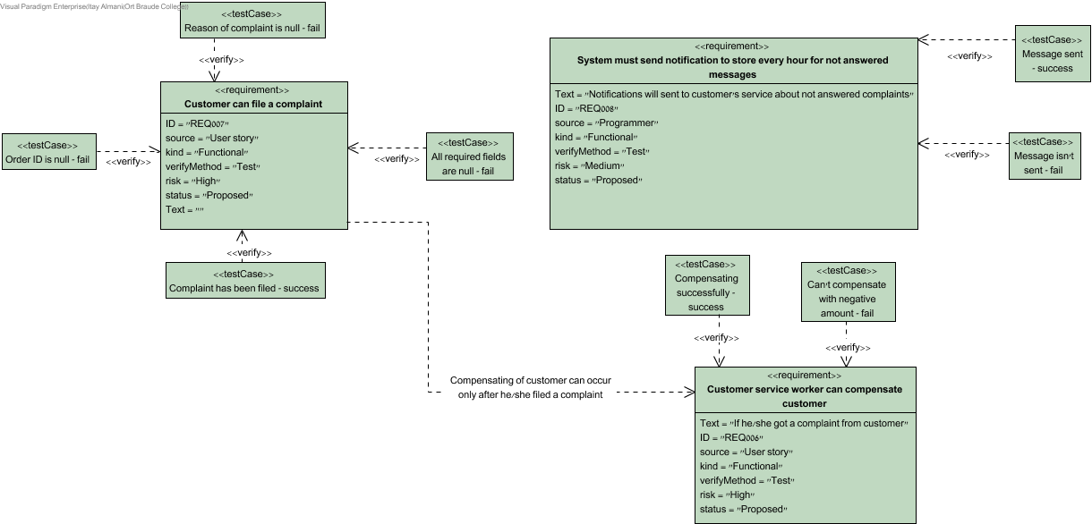

# 74. Customer can file a complaint

ID: REQ007

# 75. Complaint has been filed - success

## 75.1. Test Plans

| Steps | Procedures | Expected Results |
| --- | --- | --- |
| 1. Open complain form | Enter: Order ID:123 Reason of complain: Item received not as described | data appeared in form |
| 2. Submit the form | Click send | Prompt: Complaint has been filed! |

## 75.2. Relationships

| Relationship | From | To |
| --- | --- | --- |
| unnamed | Complaint has been filed - success | Customer can file a complaint |

# 76. Order ID is null - fail

## 76.1. Test Plans

| Steps | Procedures | Expected Results |
| --- | --- | --- |
| 1. Open complain form | Enter: Order ID:null Reason of complain: Item received not as described | data appeared in form |
| 2. Submit the form | Click send | Prompt: order ID is missing |

## 76.2. Relationships

| Relationship | From | To |
| --- | --- | --- |
| unnamed | Order ID is null - fail | Customer can file a complaint |

# 77. Reason of complaint is null - fail

## 77.1. Test Plans

| Steps | Procedures | Expected Results |
| --- | --- | --- |
| 1. Open complain form | Enter: -Order ID:123 -Reason of complain:null | data appeared in form |
| 2. Submit the form | Click send | Prompt: reason of complain is missing |

## 77.2. Relationships

| Relationship | From | To |
| --- | --- | --- |
| unnamed | Reason of complaint is null - fail | Customer can file a complaint |

# 78. All required fields are null - fail

## 78.1. Test Plans

| Steps | Procedures | Expected Results |
| --- | --- | --- |
| 1. Open complain form | Enter: Order ID:null Reason of complain: null | data appeared in form |
| 2. Submit the form | Click send | Prompt: all fields are missing |

## 78.2. Relationships

| Relationship | From | To |
| --- | --- | --- |
| unnamed | All required fields are null - fail | Customer can file a complaint |

# 79. System must send notification to store every hour for not answered messages

ID: REQ008

Notifications will sent to customer's service about not answered complaints

# 80. Message isn't sent - fail

## 80.1. Test Plans

| Steps | Procedures | Expected Results |
| --- | --- | --- |
| 1. System extracted data from DB |  | correct data is extracted |
| 2. System checks data | System checks complaint status | Message sent fail |

## 80.2. Relationships

| Relationship | From | To |
| --- | --- | --- |
| unnamed | Message isn't sent - fail | System must send notification to store every hour for not answered messages |

# 81. Message sent - success

## 81.1. Test Plans

| Steps | Procedures | Expected Results |
| --- | --- | --- |
| 1. System extracted data from DB |  | correct data is extracted |
| 2. System checks data | System checks complaint status | Message sent successfully |

## 81.2. Relationships

| Relationship | From | To |
| --- | --- | --- |
| unnamed | Message sent - success | System must send notification to store every hour for not answered messages |

# 82. Customer service worker can compensate customer

ID: REQ006

If he/she got a complaint from customer

# 83. Compensating successfully - success

## 83.1. Test Plans

| Steps | Procedures | Expected Results |
| --- | --- | --- |
| 1. Enter sum | enter: 1000 | data appeared in form |
| 2. submit the form | press update button | prompt: application submitted successfully |

## 83.2. Relationships

| Relationship | From | To |
| --- | --- | --- |
| unnamed | Compensating successfully - success | Customer service worker can compensate customer |

# 84. Can't compensate with negative amount - fail

## 84.1. Test Plans

| Steps | Procedures | Expected Results |
| --- | --- | --- |
| 1. Enter sum | enter:-1000 | data appeared in form |
| 2. submit the form | press update button | prompt: Amount can't be negative! |

## 84.2. Relationships

| Relationship | From | To |
| --- | --- | --- |
| unnamed | Can't compensate with negative amount - fail | Customer service worker can compensate customer |

# 85. RD - Management 4th

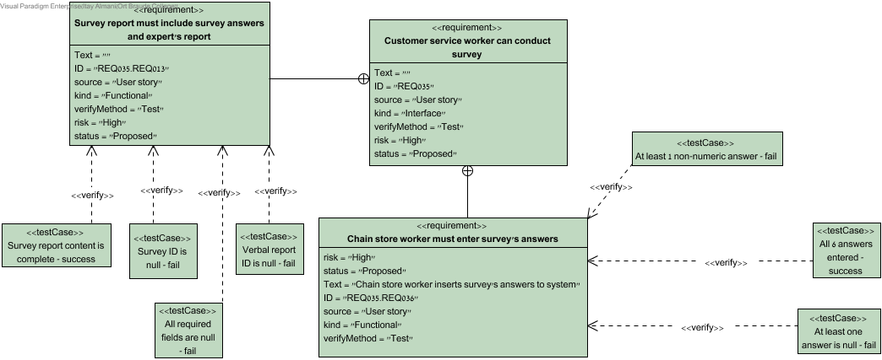

# 86. Chain store worker must enter survey's answers

ID: REQ035.REQ036

Chain store worker inserts survey's answers to system

# 87. At least one answer is null - fail

There suppose to be 6 answers which are in the range of 1-10.

One missing answer is sufficient to make the form to be invalid.

## 87.1. Test Plans

| Steps | Procedures | Expected Results |
| --- | --- | --- |
| 1. Fill the form | Enter: 5 numeric answers (between 1-10) and one is null | Data appeared in form |
| 2. Submit the form | Click send | Prompt: One or more field(s) is/are missing! |

## 87.2. Relationships

| Relationship | From | To |
| --- | --- | --- |
| unnamed | At least one answer is null - fail | Chain store worker must enter survey's answers |

# 88. At least 1 non-numeric answer - fail

## 88.1. Relationships

| Relationship | From | To |
| --- | --- | --- |
| unnamed | At least 1 non-numeric answer - fail | Chain store worker must enter survey's answers |

# 89. All 6 answers entered - success

## 89.1. Test Plans

| Steps | Procedures | Expected Results |
| --- | --- | --- |
| 1. Fill the form | Enter: 6 numeric answers (between 1-10) | Data appeared in form |
| 2. Submit the form | Click send | Prompt: Application is submitted |

## 89.2. Relationships

| Relationship | From | To |
| --- | --- | --- |
| unnamed | All 6 answers entered - success | Chain store worker must enter survey's answers |

# 90. Survey report must include survey answers and expert's report

ID: REQ035.REQ013

# 91. Survey report content is complete - success

## 91.1. Test Plans

| Steps | Procedures | Expected Results |
| --- | --- | --- |
| 1. Open survey report | Enter: -Survey ID: 1 -Verbal Report ID: 1 | Data appeared in form |
| 2. Submit the form | Click send | Prompt: Survey report created successfully |

## 91.2. Relationships

| Relationship | From | To |
| --- | --- | --- |
| unnamed | Survey report content is complete - success | Survey report must include survey answers and expert's report |

# 92. Survey ID is null - fail

## 92.1. Test Plans

| Steps | Procedures | Expected Results |
| --- | --- | --- |
| 1. Open survey report | Enter: -Survey ID: null -Verbal Report ID: 1 | Data appeared in form |
| 2. Submit the form | Click send | Prompt: Survey ID is missing |

## 92.2. Relationships

| Relationship | From | To |
| --- | --- | --- |
| unnamed | Survey ID is null - fail | Survey report must include survey answers and expert's report |

# 93. All required fields are null - fail

## 93.1. Test Plans

| Steps | Procedures | Expected Results |
| --- | --- | --- |
| 1. Open survey report | Enter: -Survey ID: null -Verbal Report ID: null | Data appeared in form |
| 2. Submit the form | Click send | Prompt: all fields are missing |

## 93.2. Relationships

| Relationship | From | To |
| --- | --- | --- |
| unnamed | All required fields are null - fail | Survey report must include survey answers and expert's report |

# 94. Verbal report ID is null - fail

## 94.1. Test Plans

| Steps | Procedures | Expected Results |
| --- | --- | --- |
| 1. Open survey report | Enter: -Survey ID: 1 -Verbal Report ID: null | Data appeared in form |
| 2. Submit the form | Click send | Prompt: Verbal report ID is missing |

## 94.2. Relationships

| Relationship | From | To |
| --- | --- | --- |
| unnamed | Verbal report ID is null - fail | Survey report must include survey answers and expert's report |

# 95. Operational monitoring

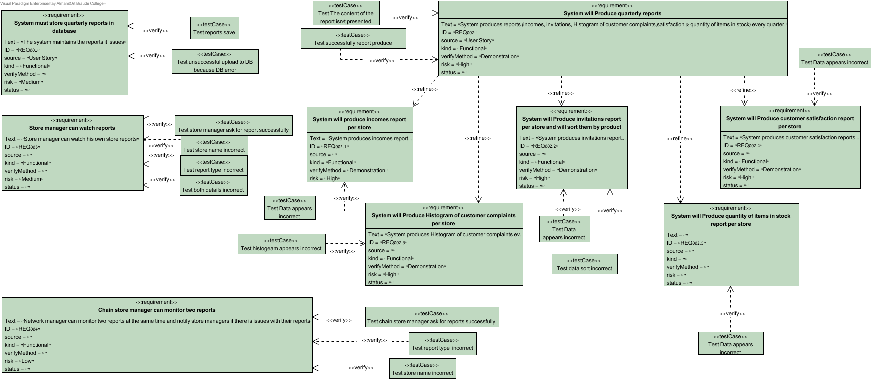

# 96. System must store quarterly reports in database

ID: REQ001

The system maintains the reports it issues

# 97. Test reports save

## 97.1. Test Plans

| Steps | Procedures | Expected Results |
| --- | --- | --- |
| 1. System insert report data into form | Enter: -report type:"incomes" -store name:"carmiel" -date:"11/11/11" | Data shown in report form |
| 2. Save to database | Save form | Data is successfully saved into DB |

## 97.2. Relationships

| Relationship | From | To |
| --- | --- | --- |
| unnamed | Test reports save | System must store quarterly reports in database |

# 98. Test unsuccessful upload to DB because DB error

unsuccessful upload to DB because DB error

## 98.1. Test Plans

| Steps | Procedures | Expected Results |
| --- | --- | --- |
| 1. System insert report data into form | Enter: -report type:"incomes" -store name:"carmiel" -date:"11/11/11" | Data shown in report form |
| 2. Save to database | Save form | Data is unsuccessfully saved into DB |

## 98.2. Relationships

| Relationship | From | To |
| --- | --- | --- |
| unnamed | Test unsuccessful upload to DB because DB error | System must store quarterly reports in database |

# 99. Store manager can watch reports

ID: REQ003

Store manager can watch his own store reports

# 100. Test store name incorrect

## 100.1. Test Plans

| Steps | Procedures | Expected Results |
| --- | --- | --- |
| 1. Store manager request | Enter: -Store name="Haifa" -report type= "Customer satisfaction" | Data shown on screen |
| 2. Submit the request | Click: -Click on submit button | Prompt: Error details incorrect |

## 100.2. Relationships

| Relationship | From | To |
| --- | --- | --- |
| unnamed | Test store name incorrect | Store manager can watch reports |

# 101. Test store manager ask for report successfully

## 101.1. Test Plans

| Steps | Procedures | Expected Results |
| --- | --- | --- |
| 1. Store manager request | Enter: -Store name= "Carmiel" -report type= "Customer satisfaction" | Data shown on screen |
| 2. Submit the request | Click: -Click on submit button | Prompt: Searching |
| 3. System pulling out report | Show: -request report | Prompt: report has been shown |

## 101.2. Relationships

| Relationship | From | To |
| --- | --- | --- |
| unnamed | Test store manager ask for report successfully | Store manager can watch reports |

# 102. Test report type incorrect

## 102.1. Test Plans

| Steps | Procedures | Expected Results |
| --- | --- | --- |
| 1. Network manager request | Enter: -First store name= "Carmiel" -Second store name="haifa" -report type= "speed" | Data shown on screen |
| 2. Submit the request | Click: -Click on submit button | Prompt: details incorrect |

## 102.2. Relationships

| Relationship | From | To |
| --- | --- | --- |
| unnamed | Test report type incorrect | Chain store manager can monitor two reports |

# 103. Test both details incorrect

## 103.1. Test Plans

| Steps | Procedures | Expected Results |
| --- | --- | --- |
| 1. Store manager request | Enter: -Store name="Haifa" -report type= "speed" | Data shown on screen |
| 2. Submit the request | Click: -Click on submit button | Prompt: Error details incorrect |

## 103.2. Relationships

| Relationship | From | To |
| --- | --- | --- |
| unnamed | Test both details incorrect | Store manager can watch reports |

# 104. Chain store manager can monitor two reports

ID: REQ004

Network manager can monitor two reports at the same time and notify store managers if there is issues with their reports

# 105. Test chain store manager ask for reports successfully

## 105.1. Test Plans

| Steps | Procedures | Expected Results |
| --- | --- | --- |
| 1. Network manager request | Enter: -First store name= "Carmiel" -Second store name="haifa" -report type= "Customer satisfaction" | Data shown on screen |
| 2. Submit the request | Click: -Click on submit button | Prompt: Searching |
| 3. System pulling out report | Show: -request report | Prompt: report has been shown |

## 105.2. Relationships

| Relationship | From | To |
| --- | --- | --- |
| unnamed | Test chain store manager ask for reports successfully | Chain store manager can monitor two reports |

# 106. Test report type incorrect

## 106.1. Test Plans

| Steps | Procedures | Expected Results |
| --- | --- | --- |
| 1. Store manager request | Enter: -Store name= "Carmiel" -report type= "Speed" | Data shown on screen |
| 2. Submit the request | Click: -Click on submit button | Prompt: Error details incorrect |

## 106.2. Relationships

| Relationship | From | To |
| --- | --- | --- |
| unnamed | Test report type incorrect | Store manager can watch reports |

# 107. Test store name incorrect

## 107.1. Test Plans

| Steps | Procedures | Expected Results |
| --- | --- | --- |
| 1. Network manager request | Enter: -First store name= "123" -Second store name="43" -report type= "Customer satisfaction" | Data shown on screen |
| 2. Submit the request | Click: -Click on submit button | Prompt: details incorrect |

## 107.2. Relationships

| Relationship | From | To |
| --- | --- | --- |
| unnamed | Test store name incorrect | Chain store manager can monitor two reports |

# 108. System will Produce quarterly reports

ID: REQ002

System produces reports (incomes, invitations, Histogram of customer complaints,satisfaction & quantity of items in stock) every quarter.

# 109. Test The content of the report isn't presented successfully

This test is for the unsuccessfully producing of all types of reports because a technical problem in the DB or form

## 109.1. Test Plans

| Steps | Procedures | Expected Results |
| --- | --- | --- |
| 1. System download details from DB | Download: -Requested data per store for every report | Data downloaded successfully |
| 2. Data inserted into form | Write: -Requested data into the form | Form data write unsuccessfully |

## 109.2. Relationships

| Relationship | From | To |
| --- | --- | --- |
| unnamed | Test The content of the report isn't presented successfully | System will Produce quarterly reports |

# 110. Test successfully report produce

This test is for the successfully producing of all types of reports

## 110.1. Test Plans

| Steps | Procedures | Expected Results |
| --- | --- | --- |
| 1. System download details from DB | Download: -Requested data per store for every report | Data downloaded successfully |
| 2. Data inserted into form | Write: -Requested data into the form | Form data inserted successfully |

## 110.2. Relationships

| Relationship | From | To |
| --- | --- | --- |
| unnamed | Test successfully report produce | System will Produce quarterly reports |

# 111. System will produce incomes report per store

ID: REQ002.1

System produces incomes reports every quarter for every store.

# 112. Test Data appears incorrect

Test case for the case when the data downloaded from DB isn't as wanted

## 112.1. Test Plans

| Steps | Procedures | Expected Results |
| --- | --- | --- |
| 1. System down load details from DB | Download: -quantity of items in stock per store | Data downloaded successfully |
| 2. Data inserted into form | Write: -quantity of items in stock data | Data downloaded is incorrect |

## 112.2. Relationships

| Relationship | From | To |
| --- | --- | --- |
| unnamed | Test Data appears incorrect | System will Produce quantity of items in stock report per store |

# 113. System will Produce Histogram of customer complaints per store

ID: REQ002.3

System produces Histogram of customer complaints every quarter for every store.

# 114. Test histogeam appears incorrect

Test case for the case when the data downloaded from DB isn't as wanted

## 114.1. Test Plans

| Steps | Procedures | Expected Results |
| --- | --- | --- |
| 1. System down load details from DB | Download: -customer complaints per store | Data downloaded successfully |
| 2. Convert the data to a histogram | Make: -Histogram from data | Histogram does not match the data downloaded |

## 114.2. Relationships

| Relationship | From | To |
| --- | --- | --- |
| unnamed | Test histogeam appears incorrect | System will Produce Histogram of customer complaints per store |

# 115. System will Produce invitations report per store and will sort them by product

ID: REQ002.2

System produces invitations reports every quarter for every store.

# 116. Test Data appears incorrect

Test case for the case when the data downloaded from DB isn't as wanted

## 116.1. Test Plans

| Steps | Procedures | Expected Results |
| --- | --- | --- |
| 1. System down load details from DB | Download: -Invitations per store | Data downloaded successfully |
| 2. Invitations sort | Sort: -Sort by product | Sorted successfully |
| 3. Data inserted into form | Write: -Invitations data | Data downloaded is incorrect |

## 116.2. Relationships

| Relationship | From | To |
| --- | --- | --- |
| unnamed | Test Data appears incorrect | System will Produce invitations report per store and will sort them by product |

# 117. Test data sort incorrect

## 117.1. Test Plans

| Steps | Procedures | Expected Results |
| --- | --- | --- |
| 1. System down load details from DB | Download: -Invitations per store | Data downloaded successfully |
| 2. Invitations sort | Sort: -Sort by product | Sort Failed |
| 3. Data inserted into form | Write: -Invitations data | Form data inserted successfully |

## 117.2. Relationships

| Relationship | From | To |
| --- | --- | --- |
| unnamed | Test data sort incorrect | System will Produce invitations report per store and will sort them by product |

# 118. System will Produce quantity of items in stock report per store

ID: REQ002.5

System produces quantity of items in stock reports every quarter for every store.

# 119. Test Data appears incorrect

Test case for the case when the data downloaded from DB isn't as wanted

## 119.1. Test Plans

| Steps | Procedures | Expected Results |
| --- | --- | --- |
| 1. System down load details from DB | Download: -Incomes per store | Data downloaded successfully |
| 2. Data inserted into form | Write: -costumer satisfaction data | Data downloaded is incorrect |

## 119.2. Relationships

| Relationship | From | To |
| --- | --- | --- |
| unnamed | Test Data appears incorrect | System will produce incomes report per store |

# 120. System will Produce customer satisfaction report per store

ID: REQ002.4

System produces customer satisfaction reports every quarter for every store.

# 121. Test Data appears incorrect

Test case for the case when the data downloaded from DB isn't as wanted

## 121.1. Test Plans

| Steps | Procedures | Expected Results |
| --- | --- | --- |
| 1. System down load details from DB | Download: -customer satisfaction per store | Data downloaded successfully |
| 2. Data inserted into form | Write: -customer satisfaction data | Data downloaded is incorrect |

## 121.2. Relationships

| Relationship | From | To |
| --- | --- | --- |
| unnamed | Test Data appears incorrect | System will Produce customer satisfaction report per store |

# 122. Requirement Diagram1

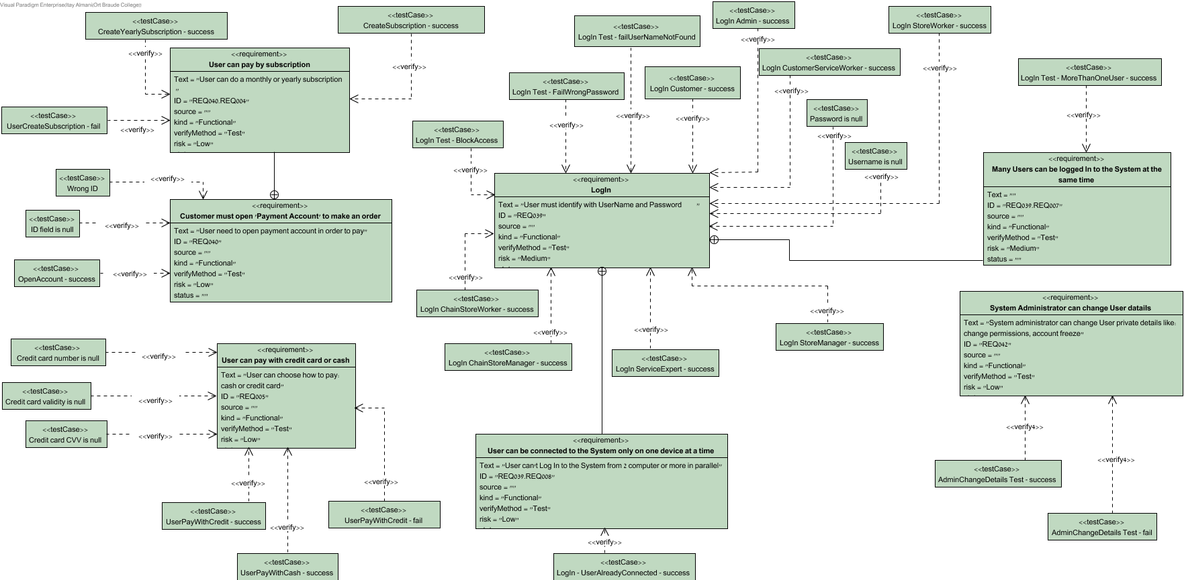

# 123. Customer must open 'Payment Account' to make an order

ID: REQ040

User need to open payment account in order to pay

# 124. Wrong ID

User Moshe Open account,

ID:204407811

ID entered: 204407823 (Error) System rejects the process

## 124.1. Test Plans

| Steps | Procedures | Expected Results |
| --- | --- | --- |
| 1. Open account | enter ID:204407823 |  |
| 2. System check ID number | ID is incorrect | System show massage: " Error ID field is incorrect" |

## 124.2. Relationships

| Relationship | From | To |
| --- | --- | --- |
| unnamed | Wrong ID | Customer must open 'Payment Account' to make an order |

# 125. ID field is null

User Moshe Open account,

ID field is NULL

System rejects the process

## 125.1. Test Plans

| Steps | Procedures | Expected Results |
| --- | --- | --- |
| 1. Open account | enter ID:NULL |  |
| 2. System check ID number |  | System show massage: " Error ID field is NULL" |

## 125.2. Relationships

| Relationship | From | To |
| --- | --- | --- |
| unnamed | ID field is null | Customer must open 'Payment Account' to make an order |

# 126. OpenAccount - success

User Moshe Open account,

ID:204407811 Account opened successfully

## 126.1. Test Plans

| Steps | Procedures | Expected Results |
| --- | --- | --- |
| 1. Open account | enter ID:204407823 |  |
| 2. System check ID number | ID is correct | System show massage:"Account opened successfully" |

## 126.2. Relationships

| Relationship | From | To |
| --- | --- | --- |
| unnamed | [OpenAccount - success](#buAXU_qGAqBwAVIF" \o "OpenAccount - success) | Customer must open 'Payment Account' to make an order |

# 127. User can pay by subscription

ID: REQ040.REQ004

User can do a monthly or yearly subscription

# 128. CreateSubscription - success

User Moshe choose create Subscription: Monthly

System create Subscription successfully.

## 128.1. Test Plans

| Steps | Procedures | Expected Results |
| --- | --- | --- |
| 1. Create Subscription | choose: Monthly |  |
| 2. |  | System show massage:" Monthly Subscription created successfully" |
| 3. |  | System return to User "Home Screen" |

## 128.2. Relationships

| Relationship | From | To |
| --- | --- | --- |
| unnamed | [CreateSubscription - success](#xCMKZfqGAqBwAQza" \o "CreateSubscription - success) | User can pay by subscription |

# 129. CreateYearlySubscription - success

User Moshe choose create Subscription: Yearly

System create Subscription successfully.

## 129.1. Test Plans

| Steps | Procedures | Expected Results |
| --- | --- | --- |
| 1. Create Subscription | choose: Yearly |  |
| 2. |  | System show massage:" Yearly Subscription created successfully" |
| 3. |  | System return to User "Home Screen" |

## 129.2. Relationships

| Relationship | From | To |
| --- | --- | --- |
| unnamed | [CreateYearlySubscription - success](#YV0KZfqGAqBwAQzH" \o "CreateYearlySubscription - success) | User can pay by subscription |

# 130. UserCreateSubscription - fail

User Moshe choose create Subscription

System can't create Subscription.

## 130.1. Test Plans

| Steps | Procedures | Expected Results |
| --- | --- | --- |
| 1. Create Subscription | choose: Yearly / Monthly |  |
| 2. |  | System show massage:" System can't create Subscription, please try again" |
| 3. |  | System retrun to User "Home Screen" |

## 130.2. Relationships

| Relationship | From | To |
| --- | --- | --- |
| unnamed | [UserCreateSubscription - fail](#hdMKZfqGAqBwAQzt" \o "UserCreateSubscription - fail) | User can pay by subscription |

# 131. User can pay with credit card or cash

ID: REQ005

User can choose how to pay:

cash or credit card

# 132. Credit card number is null

User Moshe choose payment method : credit card

Card number field is NULL

System deny payment.

## 132.1. Test Plans

| Steps | Procedures | Expected Results |
| --- | --- | --- |
| 1. choose payment method | choose: credit card |  |
| 2. TestCaseStep | enter credit card details: card_number:NULL validity:08/20 CVV: 588 |  |
| 3. System check credit card details | payment denied | System show massage: "payment denied,card number field is NULL" |

## 132.2. Relationships

| Relationship | From | To |
| --- | --- | --- |
| unnamed | Credit card number is null | User can pay with credit card or cash |

# 133. Credit card validity is null

User Moshe choose payment method : credit card

validity field is NULL

System deny payment.

## 133.1. Test Plans

| Steps | Procedures | Expected Results |
| --- | --- | --- |
| 1. choose payment method | choose: credit card |  |
| 2. TestCaseStep | enter credit card details: card_number: 4580547869854 validity:NULL CVV: 588 |  |
| 3. System check credit card details | payment denied | System show massage: "payment denied,validity field is NULL" |

## 133.2. Relationships

| Relationship | From | To |
| --- | --- | --- |
| unnamed | Credit card validity is null | User can pay with credit card or cash |

# 134. Credit card CVV is null

User Moshe choose payment method : credit card

CVV field is NULL

System deny payment.

## 134.1. Test Plans

| Steps | Procedures | Expected Results |
| --- | --- | --- |
| 1. choose payment method | choose: credit card |  |
| 2. TestCaseStep | enter credit card details: card_number: 4580547869854 validity:08/20 CVV: NULL |  |
| 3. System check credit card details | payment denied | System show massage: "payment denied, CVV field is NULL" |

## 134.2. Relationships

| Relationship | From | To |
| --- | --- | --- |
| unnamed | Credit card CVV is null | User can pay with credit card or cash |

# 135. UserPayWithCredit - fail

User Moshe choose payment method : credit card

System denied credit card details

System confirm denied.

## 135.1. Test Plans

| Steps | Procedures | Expected Results |
| --- | --- | --- |
| 1. choose payment method0 | choose: credit card |  |
| 2. | enter credit card details: card_number: 4580547869854 validity:08/20 CVV: 588 ID: 478847511 |  |
| 3. System check credit card details and ID number | credit card didn't approve | System show massage: "credit card details are Incorrect, please try again" |

## 135.2. Relationships

| Relationship | From | To |
| --- | --- | --- |
| unnamed | [UserPayWithCredit - fail](#3EPyZfqGAqBwAQw6" \o "UserPayWithCredit - fail) | User can pay with credit card or cash |

# 136. UserPayWithCredit - success

User Moshe choose payment method : credit card

System confirm payment.

## 136.1. Test Plans

| Steps | Procedures | Expected Results |
| --- | --- | --- |
| 1. choose payment method | choose: credit card |  |
| 2. | enter credit card details: card_number: 4580547869854 validity:08/20 CVV: 588 ID: 478847511 |  |
| 3. System check credit card details and ID number | all details are approved | System show massage: "payment confirm" |
| 4. |  | System send order bill to user Email |

## 136.2. Relationships

| Relationship | From | To |
| --- | --- | --- |
| unnamed | [UserPayWithCredit - success](#GAfyZfqGAqBwAQxU" \o "UserPayWithCredit - success) | User can pay with credit card or cash |

# 137. UserPayWithCash - success

User Moshe choose payment method : cash

System confirm payment.

## 137.1. Test Plans

| Steps | Procedures | Expected Results |
| --- | --- | --- |
| 1. choose payment method | choose: cash |  |
| 2. |  | System show massage: "payment will be complete on delivery/with cashier " |
| 3. |  | System send order bill to user Email |

## 137.2. Relationships

| Relationship | From | To |
| --- | --- | --- |
| unnamed | [UserPayWithCash - success](#4O3yZfqGAqBwAQwk" \o "UserPayWithCash - success) | User can pay with credit card or cash |

# 138. LogIn

ID: REQ039

User must identify with UserName and Password

# 139. LogIn

ID: REQ039

User must identify with UserName and Password

## 139.1. Stereotypes

<<requirement>>

## 139.2. Tagged Values

| Name | Type | Value |
| --- | --- | --- |
| ID | Text | REQ039 |
| kind | Ad Hoc Enumeration | Functional |
| risk | Ad Hoc Enumeration | Medium |
| source | Text |  |
| status | Ad Hoc Enumeration |  |
| Text | HTML | User must identify with UserName and Password |
| verifyMethod | Ad Hoc Enumeration | Test |

## 139.3. Properties

|  |  |
| --- | --- |
| Source | N/A |
| Kind | Functional |
| Verify method | Test |
| Risk | Medium |
| Status | N/A |

## 139.4. Relationships

| Relationship | From | To |
| --- | --- | --- |
| unnamed | [LogIn Customer - success](#t8vYZfqGAqBwAQjt" \o "LogIn Customer - success) | [LogIn](#iGyYpfqGAqBwAQoH" \o "LogIn) |
| unnamed | [LogIn Test - failUserNameNotFound](#DjfYZfqGAqBwAQkE" \o "LogIn Test - failUserNameNotFound) | [LogIn](#iGyYpfqGAqBwAQoH" \o "LogIn) |
| unnamed | [LogIn Test - FailWrongPassword](#Z2A4ZfqGAqBwAQki" \o "LogIn Test - FailWrongPassword) | [LogIn](#iGyYpfqGAqBwAQoH" \o "LogIn) |
| unnamed | [LogIn Test - BlockAccess](#WJR0ZfqGAqBwAQjM" \o "LogIn Test - BlockAccess) | [LogIn](#iGyYpfqGAqBwAQoH" \o "LogIn) |
| unnamed | Password is null | [LogIn](#iGyYpfqGAqBwAQoH" \o "LogIn) |
| unnamed | Username is null | [LogIn](#iGyYpfqGAqBwAQoH" \o "LogIn) |
| unnamed | [LogIn CustomerServiceWorker - success](#50JWk_qGAqBwAWuP" \o "LogIn CustomerServiceWorker - success) | [LogIn](#iGyYpfqGAqBwAQoH" \o "LogIn) |
| unnamed | [LogIn ServiceExpert - success](#PjJWk_qGAqBwAW.2" \o "LogIn ServiceExpert - success) | [LogIn](#iGyYpfqGAqBwAQoH" \o "LogIn) |
| unnamed | [LogIn StoreManager - success](#gqpWk_qGAqBwAW_J" \o "LogIn StoreManager - success) | [LogIn](#iGyYpfqGAqBwAQoH" \o "LogIn) |
| unnamed | [LogIn ChainStoreManager - success](#AkZWk_qGAqBwAW_c" \o "LogIn ChainStoreManager - success) | [LogIn](#iGyYpfqGAqBwAQoH" \o "LogIn) |
| unnamed | [LogIn StoreWorker - success](#ETZWk_qGAqBwAW_v" \o "LogIn StoreWorker - success) | [LogIn](#iGyYpfqGAqBwAQoH" \o "LogIn) |
| unnamed | [LogIn Admin - success](#tqFWk_qGAqBwAXAM" \o "LogIn Admin - success) | [LogIn](#iGyYpfqGAqBwAQoH" \o "LogIn) |
| unnamed | [LogIn ChainStoreWorker - success](#Wbjuk_qGAqBwAXLD" \o "LogIn ChainStoreWorker - success) | LogIn |

# 140. LogIn StoreWorker - success

Store Worker Ronen with:

Store Worker "IsConnecting" - "False"

Username: Ronen

Password: 12345

Log in successfully to System.

## 140.1. Test Plans

| Steps | Procedures | Expected Results |
| --- | --- | --- |
| 1. Enter User information | Enter: Username:Ronen Password:12345 User press "LogIn" button |  |
| 2.  check User details |  | System move app to next screen |
| 3. change connection status |  | System change " Is_Connecting" of user to "True |

## 140.2. Relationships

| Relationship | From | To |
| --- | --- | --- |
| unnamed | [LogIn StoreWorker - success](#ETZWk_qGAqBwAW_v" \o "LogIn StoreWorker - success) | [LogIn](#iGyYpfqGAqBwAQoH" \o "LogIn) |

# 141. LogIn Admin - success

Admin Avi with:

Admin "IsConnecting" - "False"

Username: Avi

Password: 12345

Log in successfully to System.

## 141.1. Test Plans

| Steps | Procedures | Expected Results |
| --- | --- | --- |
| 1. Enter User information | Enter: Username: Avi, Password:12345, User press "LogIn" button |  |
| 2.  check User details |  | System move app to next screen |
| 3. change connection status |  | System change " Is_Connecting" of user to "True |

## 141.2. Relationships

| Relationship | From | To |
| --- | --- | --- |
| unnamed | [LogIn Admin - success](#tqFWk_qGAqBwAXAM" \o "LogIn Admin - success) | [LogIn](#iGyYpfqGAqBwAQoH" \o "LogIn) |

# 142. LogIn CustomerServiceWorker - success

Customer's Service Worker Nir with:

Customer's Service Worker "IsConnecting" - "False"

Username: Nir

Password: 12345

Log in successfully to System.

## 142.1. Test Plans

| Steps | Procedures | Expected Results |
| --- | --- | --- |
| 1. Enter User information | Enter: Username: Nir, Password:12345, User press "LogIn" button |  |
| 2.  check User details |  | System move app to next screen |
| 3. change connection status |  | System change " Is_Connecting" of user to "True |

## 142.2. Relationships

| Relationship | From | To |
| --- | --- | --- |
| unnamed | [LogIn CustomerServiceWorker - success](#50JWk_qGAqBwAWuP" \o "LogIn CustomerServiceWorker - success) | [LogIn](#iGyYpfqGAqBwAQoH" \o "LogIn) |

# 143. LogIn Customer - success

Customer Moshe with:

Customer "IsConnecting" - "False"

Username: Moshe

Password: 12345

Log in successfully to System.

## 143.1. Test Plans

| Steps | Procedures | Expected Results |
| --- | --- | --- |
| 1. Enter User information | Enter: Username:MoshePassword:12345,User press "LogIn" button |  |
| 2.  check User details |  | System move app to next screen |
| 3. change connection status |  | System change " Is_Connecting" of user to "True |

## 143.2. Relationships

| Relationship | From | To |
| --- | --- | --- |
| unnamed | [LogIn Customer - success](#t8vYZfqGAqBwAQjt" \o "LogIn Customer - success) | [LogIn](#iGyYpfqGAqBwAQoH" \o "LogIn) |

# 144. LogIn ChainStoreWorker - success

Chain Store Manager Itay with:

Chain Store Manager "IsConnecting" - "False"

Username: Itay

Password: 12345

Log in successfully to System.

## 144.1. Test Plans

| Steps | Procedures | Expected Results |
| --- | --- | --- |
| 1. Enter User information | Enter: Username:Itay Password:12345 User press "LogIn" button |  |
| 2.  check User details |  | System move app to next screen |
| 3. change connection status |  | System change " Is_Connecting" of user to "True |

## 144.2. Relationships

| Relationship | From | To |
| --- | --- | --- |
| unnamed | [LogIn ChainStoreWorker - success](#Wbjuk_qGAqBwAXLD" \o "LogIn ChainStoreWorker - success) | [LogIn](#iGyYpfqGAqBwAQoH" \o "LogIn) |

# 145. LogIn ChainStoreManager - success

Chain Store Manager Ron with:

Chain Store Manager "IsConnecting" - "False"

Username: Ron

Password: 12345

Log in successfully to System.

## 145.1. Test Plans

| Steps | Procedures | Expected Results |
| --- | --- | --- |
| 1. Enter User information | Enter: Username:Ron Password:12345 User press "LogIn" button |  |
| 2.  check User details |  | System move app to next screen |
| 3. change connection status |  | System change " Is_Connecting" of user to "True |

## 145.2. Relationships

| Relationship | From | To |
| --- | --- | --- |
| unnamed | [LogIn ChainStoreManager - success](#AkZWk_qGAqBwAW_c" \o "LogIn ChainStoreManager - success) | [LogIn](#iGyYpfqGAqBwAQoH" \o "LogIn) |

# 146. LogIn ServiceExpert - success

Service Expert Ariel with:

Service Expert "IsConnecting" - "False"

Username: Ariel

Password: 12345

Log in successfully to System.

## 146.1. Test Plans

| Steps | Procedures | Expected Results |
| --- | --- | --- |
| 1. Enter User information | Enter: Username:Ariel Password:12345 User press "LogIn" button |  |
| 2.  check User details |  | System move app to next screen |
| 3. change connection status |  | System change " Is_Connecting" of user to "True |

## 146.2. Relationships

| Relationship | From | To |
| --- | --- | --- |
| unnamed | [LogIn ServiceExpert - success](#PjJWk_qGAqBwAW.2" \o "LogIn ServiceExpert - success) | [LogIn](#iGyYpfqGAqBwAQoH" \o "LogIn) |

# 147. LogIn StoreManager - success

Store Manager Lior with:

Store Manager "IsConnecting" - "False"

Username: Lior

Password: 12345

Log in successfully to System.

## 147.1. Test Plans

| Steps | Procedures | Expected Results |
| --- | --- | --- |
| 1. Enter User information | Enter: Username:Lior Password:12345 User press "LogIn" button |  |
| 2.  check User details |  | System move app to next screen |
| 3. change connection status |  | System change "Is_Connecting" of user to "True |

## 147.2. Relationships

| Relationship | From | To |
| --- | --- | --- |
| unnamed | [LogIn StoreManager - success](#gqpWk_qGAqBwAW_J" \o "LogIn StoreManager - success) | [LogIn](#iGyYpfqGAqBwAQoH" \o "LogIn) |

# 148. Username is null

User Moshe with:

User "IsConnecting" - "False"

Username: Moshe

Password: 12345

Username is NULL

Log In failed

## 148.1. Test Plans

| Steps | Procedures | Expected Results |
| --- | --- | --- |
| 1. Enter User information | Enter: Username:NULL, Password:12345, User press "LogIn" button |  |
| 2.  check User details |  | System show: "Error password/username field is empty, please try again" |

## 148.2. Relationships

| Relationship | From | To |
| --- | --- | --- |
| unnamed | Username is null | [LogIn](#iGyYpfqGAqBwAQoH" \o "LogIn) |

# 149. Password is null

User Moshe with:

User "IsConnecting" - "False"

Username: Moshe

Password: 12345

Password is NULL

Log In failed

## 149.1. Test Plans

| Steps | Procedures | Expected Results |
| --- | --- | --- |
| 1. Enter User information | Enter: Username:MoshePassword:NULL, User press "LogIn" button |  |
| 2.  check User details |  | System show: "Error password/username field is empty, please try again" |

## 149.2. Relationships

| Relationship | From | To |
| --- | --- | --- |
| unnamed | Password is null | [LogIn](#iGyYpfqGAqBwAQoH" \o "LogIn) |

# 150. LogIn Test - BlockAccess

User try 3 times to enter System ( numberOfFailed's - 3)

Log In failed

System Block user access

## 150.1. Test Plans

| Steps | Procedures | Expected Results |
| --- | --- | --- |
| 1. check user details |  | System show massage: "Access blocked, please call Technical Support" |
| 2. |  | System disable "LogIn" option |

## 150.2. Relationships

| Relationship | From | To |
| --- | --- | --- |
| unnamed | [LogIn Test - BlockAccess](#WJR0ZfqGAqBwAQjM" \o "LogIn Test - BlockAccess) | [LogIn](#iGyYpfqGAqBwAQoH" \o "LogIn) |

# 151. LogIn Test - failUserNameNotFound

User Moshe with:

User "IsConnecting" - "False"

Username: Moshe

Password: 12345

Username Not found in the System,

Log In failed

## 151.1. Test Plans

| Steps | Procedures | Expected Results |
| --- | --- | --- |
| 1. 1. Enter user information | Enter: Username: Moshe, Password: 12345, User press "LogIn" button |  |
| 2. check user details |  | System show massage: "user "Moshe" is not found in System, Please try again" |

## 151.2. Relationships

| Relationship | From | To |
| --- | --- | --- |
| unnamed | [LogIn Test - failUserNameNotFound](#DjfYZfqGAqBwAQkE" \o "LogIn Test - failUserNameNotFound) | [LogIn](#iGyYpfqGAqBwAQoH" \o "LogIn) |

# 152. LogIn Test - FailWrongPassword

User Moshe with:

User "IsConnecting" - "False"

Username: Moshe

Password: 12345

Username found in the System,

Password is incorrect

Log In failed

## 152.1. Test Plans

| Steps | Procedures | Expected Results |
| --- | --- | --- |
| 1. 1. Enter user information | Enter: Username: Moshe, Password: 12345, User press "LogIn" button |  |
| 2. check user details |  | System show massage: "user "Moshe" is not found in System, Please try again" |

## 152.2. Relationships

| Relationship | From | To |
| --- | --- | --- |
| unnamed | [LogIn Test - FailWrongPassword](#Z2A4ZfqGAqBwAQki" \o "LogIn Test - FailWrongPassword) | [LogIn](#iGyYpfqGAqBwAQoH" \o "LogIn) |

# 153. User can be connected to the System only on one device at a time

ID: REQ039.REQ008

User can't Log In to the System from 2 computer or more in parallel

# 154. LogIn - UserAlreadyConnected - success

User Moshe with:

User "IsConnecting" - "True"

Username: Moshe

Password: 12345

User is already connected

Log In cancel

## 154.1. Test Plans

| Steps | Procedures | Expected Results |
| --- | --- | --- |
| 1. 1. Enter user information | Enter: Username: Moshe, Password: 12345, User press "LogIn" button |  |
| 2. If "Is_Connecting" is 'True' user can't connect |  | System show massage: "user "Moshe" is already connected to System" |

## 154.2. Relationships

| Relationship | From | To |
| --- | --- | --- |
| unnamed | [LogIn - UserAlreadyConnected - success](#mA04ZfqGAqBwAQl7" \o "LogIn - UserAlreadyConnected - success) | User can be connected to the System only on one device at a time |

# 155. Many Users can be logged In to the System at the same time

ID: REQ039.REQ007

# 156. LogIn Test - MoreThanOneUser - success

User Moshe with:

User "IsConnecting" - "False"

Username: Moshe

Password: 12345

Log in successfully to System.

User Yossi with:

User "IsConnecting" - "False"

Username: Yossi

Password: 052516

Log in successfully to System.

Moshe and Yossi are both contacted to the System

## 156.1. Test Plans

| Steps | Procedures | Expected Results |
| --- | --- | --- |
| 1.  Enter user information | Enter: Username: Moshe, Password: 12345, User press "LogIn" button |  |
| 2. system check user details |  | System change " Is_Connecting" of user to "True |
| 3.  Enter user information | Enter: Username: Yossi, Password: 052516, User press "LogIn" button |  |
| 4. system check user details |  | System change " Is_Connecting" of user to "True |

## 156.2. Relationships

| Relationship | From | To |
| --- | --- | --- |
| unnamed | [LogIn Test - MoreThanOneUser - success](#u2E4ZfqGAqBwAQlg" \o "LogIn Test - MoreThanOneUser - success) | Many Users can be logged In to the System at the same time |

# 157. System Administrator can change User datails

ID: REQ042

System administrator can change User private details like: change permissions, account freeze

# 158. AdminChangeDetails Test - fail

Admin change User - Moshe's access

System show error message

User detail's update fail

## 158.1. Test Plans

| Steps | Procedures | Expected Results |
| --- | --- | --- |
| 1. Choose User to update | admin press "Edit users" button |  |
| 2. | admin choose: Username: Moshe, press "change access" to block |  |
| 3. |  | System show massage:"User update fail,please try again" |

## 158.2. Relationships

| Relationship | From | To |
| --- | --- | --- |
| unnamed | [AdminChangeDetails Test - fail](#LY84ZfqGAqBwAQmu" \o "AdminChangeDetails Test - fail) | System Administrator can change User datails |

# 159. AdminChangeDetails Test - success

Admin change User - Moshe's access

User detail update successfully

## 159.1. Test Plans

| Steps | Procedures | Expected Results |
| --- | --- | --- |
| 1. Choose User to update | admin press "Edit users" button |  |
| 2. | admin choose: Username: Moshe, press "change access" to block |  |

## 159.2. Relationships

| Relationship | From | To |
| --- | --- | --- |
| unnamed | [AdminChangeDetails Test - success](#RMc4ZfqGAqBwAQmb" \o "AdminChangeDetails Test - success) | System Administrator can change User datails |